Quiz 1 ***(CSE331L.7 – Asif Ahmed Neloy_Summer’20)***

Department of Electrical and Computer Engineering

School of Engineering and Physical Sciences

North South University, Bashundhara, Dhaka-1229, Bangladesh

*Time 20 minutes, Marks 20 (You need to answer all questions).*

***Name -Umme Kulsum Ritu***

***ID – 1511619042 5/10***

1. **Why it is never a good idea to store any data in the segment registers?[5]**

**Ans: It is never a good idea to store any data in the segment registers because segment registers don’t store data. Segments registers are just pointers of base address of empty blocks of memory.**

**(copy)**

1. **Write a program in Assembly language that will add 4 integer number (1,2,2,1) using only AX register and Store the result in the AX register.**

**org 100h**

**MOV AX,01**

**ADD AX,02**

**ADD AX,02**

**ADD AX,01**

**ret**

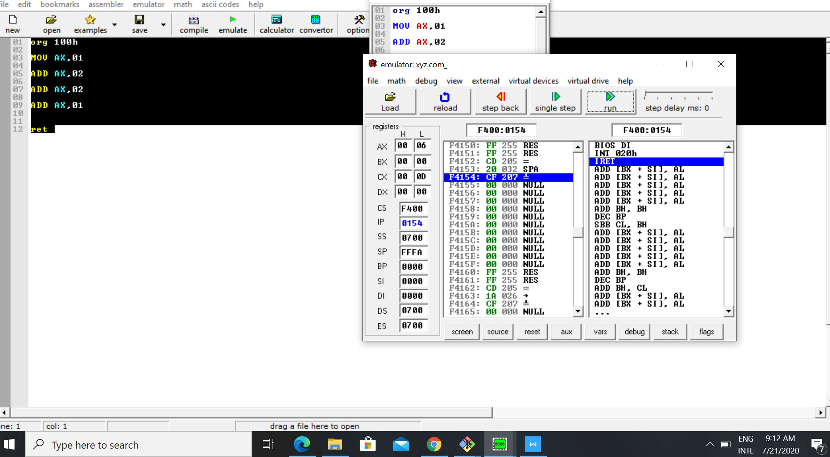

**End**